UNIT 7 – USE MAPPING DIAGRAMS

*Do Unit 5 together with this, a lot of the stuff just translates*

*Do 7.9 and 7.11 for exam prep (and assignment)*

# Surjective Functions (or Onto Functions)

* Normal functions map from one set to another
* We map from x (domain) to y (codomain).
* With surjective functions we map backwards, from y to x.
* All the elements in y have to be mapped onto. If one element is not mapped to an x, the function is not surjective.

# Injective Functions

* Normal functions map from one set to another
* This is easier, only one x can map to one y
* Even if the is one y that doesn’t link to an x, the function is Injective. In this case the function would not be surjective.

# Bijective Functions

* Function which is both Surjective and Injective. (NB iff)
* It maps one to one (Injective) and can be mapped backwards (Surjective).

# Invertible Functions

* Functions can have inverses.
* An inverse of a function is basically swapping the co-ordinates of ordered pairs
* So if you have a function going A to B, if it is invertible, there is a function that goes B to A

How to identify: iff the function is bijective, it is invertible

# Identity functions

* Functions can have equality relations which are basically identities
* They are identified with $i_{B}$

$i_{B}$: B $→$ B,

NB: A set where would have the same x and y coordinates.

Example

B = {1,2,3,4}

Therefore, $i_{B}$ = B $→$ B = {(1,1),(2,2),(3,3),(4,4)}

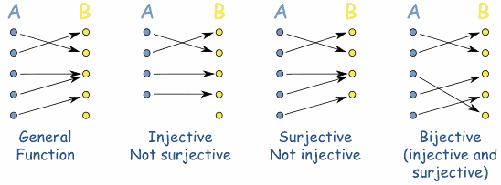

Surjective

Function

Surjective

Function

Surjective

Function

Composition

Any

Function

Any

Function

Function

Composition